CYBERQUOTE PTE LTD

Sales Performance Management
Phase III

Program Design Specification
- Leads Data

For: | CYBERQUOTE PTE LTD | Project Ref: | PM1001
Author: | Than Htike Aung | Doc Ref: | SpmPhaseIII-TS-PS-LeadsDatap-1.0
Proj Mgr: | Ei Ei Thu | Version: | 1.0
Date: | 21/10/2011 | Classification:
To : |  | Cc:

Document Revision History

Document Title : SPM Phase III Program Design Specification – Leads Data Ver 1.0

Version | Revised by | Effective Date | Summary of Change | Reason for change
1.0 | Than Htike Aung | 21/10/2011 | New Document | -

Table of Contents

1 Program Definition 3
1.1 System Name 3
1.2 Program Description 3
1.3 Programming Language/Version 3
1.4 Drivers Required/Version 3
2 Structure Design 3
2.1 Block Chart or Flow Chart on top level structure of the program 3
2.1.1 Presentation Layer 3
2.1.2 Web Service Layer 4
2.2 Description of each module 5
2.2.1 Presentation Layer 5
2.2.2 WebService Layer 6
2.3 Description of Stored Procedures used 7
3 Input/Output files used 7
3.1 Input/Output file format design (with Samples attached) 7
3.2 Database connections used 7
4 Error Message/Warning Message List 7
5 Program List 7
6 Acceptance Form 8

Program Definition

System Name
Sales Performance Management (hereinafter referred as SPM) system Phase III

Program Description
This is the program design specification of “Leads Data” function which is defined under “Leads Data” in the design specification.

Programming Language/Version
This program will be developed in C# using Visual Studio 2008 for running under ASP.net 3.5.

Drivers Required/Version
The ASP.NET AJAX 1.0 is required to support Ajax in ASP.NET environment.

Structure Design

Block Chart or Flow Chart on top level structure of the program

Presentation Layer
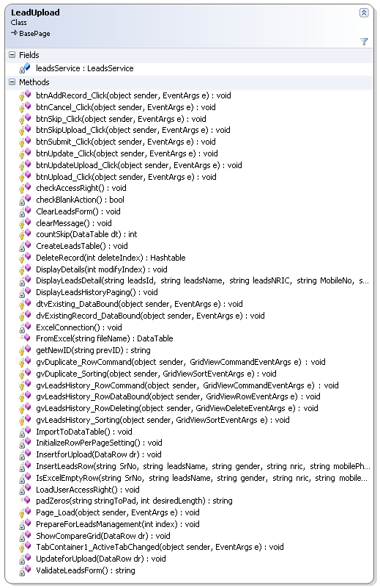
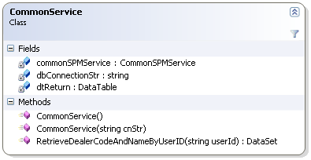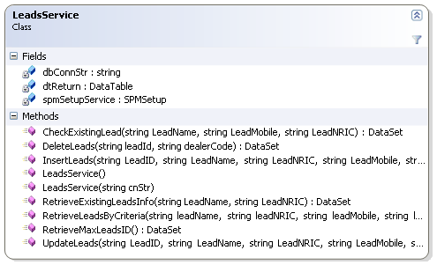

Web Service Layer
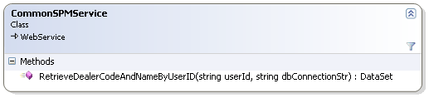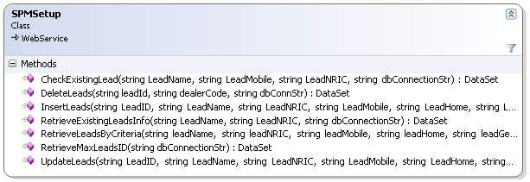

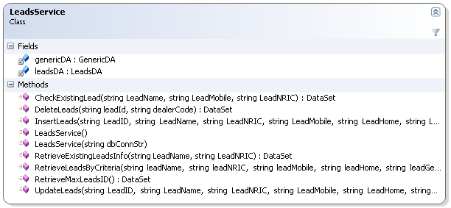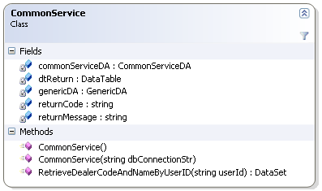
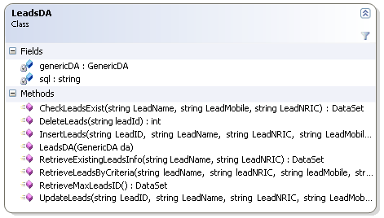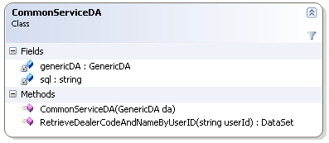

Description of each module

Presentation Layer

LeadUpload.aspx.cs
Member | Description
Fields
leadsService | Control for accessing Leads web service layer.
Methods
CheckAccessRight | Check create access right to Lead Upload
DeleteRecord | Delete Lead record
DisplayLeadsDetail | Fill in the lead detail to render in UI
ExcelConnection | Get the OLEDB Excel connection
LoadUserAccessRight | Loading user access right to LeadUpload module
PrepareForLeadsManagement | Initialize the Lead Form
ShowCompareGrid | Displaying duplicate lead record in grid
ValidateLeadsForm | Validate Lead entry form

CommonService.cs
Member | Description
Fields
dbConnectionStr | Database connection string
commonSPMService | Reference of the Common SPM web service
dtReturn | Return Datatable
Methods
RetrieveDealerCodeAndNameByUserID | Fetching Dealer Code and Name by User Id

LeadsService.cs
Member | Description
Fields
dbConnectionStr | Database connection string
spmSetUpService | Reference of the SPM Setup web service
dtReturn | Return Datatable
Methods
CheckExistingLead | Fetch the Lead information that is already exist in database to validate with new Lead Info
DeleteLeads | Delete Leads from database
InsertLeads | Insert new leads record
RetrieveExistingLeadsInfo | Fetch all existing leads information
RetrieveLeadsByCriteria | Fetch leads information by user criteria
RetrieveMaxLeadsID | Fetch Maximum leads ID from database
UpdateLeads | Update existing leads information

WebService Layer

CommonSPMService.asmx.cs
Member | Description
Methods
RetrieveDealerCodeAndNameByUserId | Fetching Dealer Code and Name by User Id

SPMSetup.asmx..cs
Member | Description
Methods
CheckExistingLead | Fetch the Lead information that is already exist in database to validate with new Lead Info
DeleteLeads | Delete Leads from database
InsertLeads | Insert new leads record
RetrieveExistingLeadsInfo | Fetch all existing leads information
RetrieveLeadsByCriteria | Fetch leads information by user criteria
RetrieveMaxLeadsID | Fetch Maximum leads ID from database
UpdateLeads | Update existing leads information

CommonService.cs
Member | Description
Fields
commonServiceDA | Common service data access layer
genericDA | Generic data access layer
dtReturn | Return Datatable
Methods
RetrieveDealerCodeAndNameByUserID | Fetching Dealer Code and Name by User Id

LeadsService.cs
Member | Description
Fields
leadsDA | Leads service data access layer
genericDA | Generic data access layer
Methods
CheckExistingLead | Fetch the Lead information that is already exist in database to validate with new Lead Info
DeleteLeads | Delete Leads from database
InsertLeads | Insert new leads record
RetrieveExistingLeadsInfo | Fetch all existing leads information
RetrieveLeadsByCriteria | Fetch leads information by user criteria
RetrieveMaxLeadsID | Fetch Maximum leads ID from database
UpdateLeads | Update existing leads information

CommonServiceDA.cs
Member | Description
Fields
genericDA | Generic data access layer
sql | Query String variable
Methods
RetrieveDealerCodeAndNameByUserID | Fetching Dealer Code and Name by User Id

LeadsDA.cs
Member | Description
Fields
genericDA | Generic data access layer
Methods
CheckExistingLead | Fetch the Lead information that is already exist in database to validate with new Lead Info
DeleteLeads | Delete Leads from database
InsertLeads | Insert new leads record
RetrieveExistingLeadsInfo | Fetch all existing leads information
RetrieveLeadsByCriteria | Fetch leads information by user criteria
RetrieveMaxLeadsID | Fetch Maximum leads ID from database
UpdateLeads | Update existing leads information

Description of Stored Procedures used
None

Input/Output files used
None

Input/Output file format design (with Samples attached)
N/A

Database connections used
BasePage.dbConnectionStr

Error Message/Warning Message List
Message | Cause
“Leads already exist!.” | When the leads information is already in database
“Error in checking leads! Please try again. Exception Message” [Error] | When system failed to retrieve leads from database.
“Error in deleting Leads record! Leads has been deleted by other user!” | When system failed to delete leads record from database.
“Error in deleting lead contact record!Please try again.Exception Message” [Error] | When system failed to update leads contact record into database.
“Error in inserting leads! Please try again. Exception Message” [Error] | When system failed to insert leads into database.
“Error in retrieving leads!Please try again.Exception Message” [Error] | When system failed to retrieve leads information from database
“No leads found! Please change your criteria” | When there is no record found in retrieving leads with criteria from database
“Error in retrieving leads! Please try again. Exception Message” [Error] | When system failed to retrieve leads from database
“Error in retrieving maximum leads id record” | When system failed to retrieve maximum lead id from database
“Leads has been update by other user! Please retrieve again.” | When the leads information is updated by other user in database
“Error in updating Leads! Please try again. Exception Message “ [Error] | When system failed to update leads record from database
Problem in WebService Connection! | When system failed to call web service

Program List
SPMWebApp\Services
CommonService.cs
LeadsService

SPMWebApp\WebPages\LeadManagement
LeadUpload.aspx
LeadUpload.aspx.cs
LeadUpload.aspx.designer.cs

SPMWebServiceApp\WebServices
CommonSPMService.asmx
CommonSPMService.asmx.cs
SPMSetup.asmx
SPMSetup.asmx.cs

SPMWebServiceApp\Services
CommonService.cs
LeadsService.cs

SPMWebServiceApp\DataAccess
LeadsDA.cs
CommonServiceDA.cs

Acceptance Form

Project Name : | Sales Performance Management Phase III
Document Name : | Program Design Specification – Leads Data  (Doc Ref: SpmPhaseIII-TS-PS-LeadsData-1.0)
Company Name : | CyberQuote Pte Ltd
Project Manager : | Ei Ei Thu
Designation :
Signature/Date :

